Chapter 2

**METHODOLOGY**

This chapter discusses the concepts and processes of handling and providing the proposed system for Bolinao Tourism entitled "Tourism Monitoring System for Bolinao.

# Project Framework

The proponents used a project framework to understand the project development better, as shown in Table 1.

Table 1:

Input Process Output Framework Model

| **INPUT** | **PROCESS** | **OUTPUT** |
| --- | --- | --- |
| **Knowledge Requirements**   * Research on the background of the proposed study. * Review on related studies and literatures * Brainstorming   **Software Requirements**   * Identification of tools that will be used in the project (Microsoft Visual Code, Laravel PHP, Figma, Trello etc.)   **Hardware Requirements**   * Processor: Core i3/ Ryzen 3 * Disk space: 10 Gigabyte (GB) * Memory: 4 Gigabyte (GB) RAM * Network Interface Card with RJ-45 cables / Wi-Fi | **Initiation**   * Identify existing process in the system. * Identify user requirements. * Identify & Assign scrum roles.   **Planning and Estimation**   * Product Backlog Creation. * Sprint Initiation. * Initial Prototype and Design. * Create process workflow. * Scrum Board Creation.   **Implementation**   * Sprint Implementation. * Coding / Development of system. * Sprint Iterations.   **Reviewing**   * Scrum Meeting. * Testing of System. * Bug-fixes.   **Releasing**   * Deployment of the system. * (optional) Retrospective Meeting. | **Tourism Monitoring System for Bolinao**  **Tourism Monitoring System for Bolinao** |

By understanding the previous processes and activities of Bolinao Tourism, identifying the requirements and core data would help develop the proposed system. The incorporation of tools required for data gathering, data analysis, and system development is done by the proponents, primarily the Trello Board collaborative tool, to make sure that the proponents would be consistent in the system proposed. The proponents distinguished the programming language and frameworks helpful in meeting the study's objectives. The final course of the proponents leads to testing the system process and creating reviews for errors and bug fixes.

# Project Design

Scrum is the recommended software methodology that the proponents have chosen for this study. Scrum is an Agile Development methodology that uses iterative and incremental processes to develop software. Scrum is an Agile framework that aims to provide value to the customer throughout the project's life cycle. It is adaptable, fast, flexible, and effective. Scrum's primary goal is to meet the customer's needs by creating an environment of open communication, shared responsibility, and continuous improvement. The development process begins with a general idea of what needs to be built, followed by creating a list of characteristics ordered by priority (product backlog) that the product owner desires.

Scrum is conducted in short, periodic blocks called Sprints, which typically last two to four weeks and are used for feedback and reflection. Each Sprint is its entity, delivering a complete result, a variant of the final product that must be delivered to the client with the least effort possible when requested.

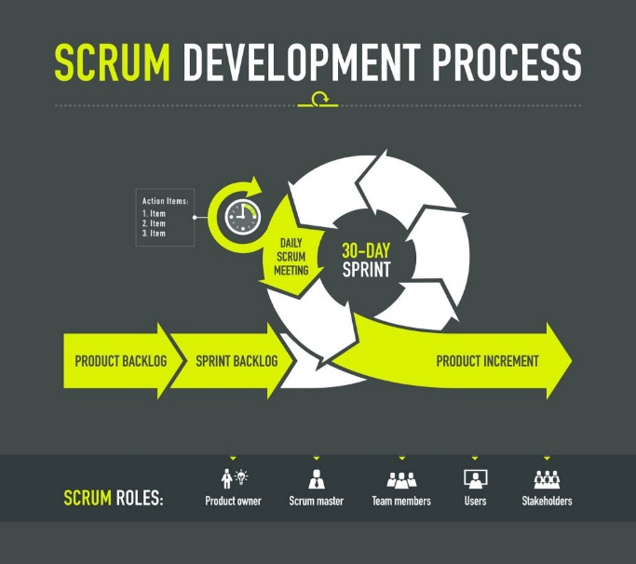Source:( <https://www.digite.com/agile/scrum-methodology/#scrum-process> )

Figure 1:

Scrum Model

The proponents used Scrum Methodology due to its nature of easier scalability. The model is innovative and experimental to the proponents, which allows for a better focus on the definite functionalities of the proposed system. Scrum promotes a cross-functional team that is self-functioning, which makes the proponents more efficient in handling tasks.

The model delivers shorter, separate projects that could help the proponents to evaluate the system after the end of each Sprint. The proponents used the model for its flexibility to change, which makes the proponents adapt to the proposed system's changing requirements. The Scrum Model provides the following benefits to the proponents: (1) Flexibility and adaptability, (2) Creativity and Innovation, (3) Improved Product Quality; and (4) Stakeholder Satisfaction.

**Scrum 3-5-3 Structure**

The proponents followed the practice of the 3-5-3 structure of the Scrum Methodology, which is: 3 roles, 5 phases, and 3 artifacts.

**Roles in Scrum**

The proponents identified the following core roles based on the Scrum Methodology.

The Scrum Master. The scrum master is the scrum development process's facilitator. The Scrum Master is responsible for keeping Scrum up to date, as well as providing coaching, mentoring, and training to the teams as needed.

The proponents discussed the responsibility of this core role in scrum and voted who would be the first Scrum Master. In the middle of the phases, rotation schedule for Scrum Master role was implemented.

Product Owner. Is the voice of the stakeholders/users. They communicate the project's vision to the scrum team, validate the benefits in stories that will be added to the Product Backlog, and prioritize them on a regular basis.

The proponents assigned the role of the stakeholders to a representative from the Tourism Office of Bolinao. After being assigned, the proponents then discussed their roles in the following phases of the system's development.

The Scrum Team. Scrum team members self-administer tasks and share responsibility for meeting each sprint's objectives.

The proponents are the core scrum team of the project, which had self-administered tasks to each other and further reminded responsibilities assigned, perform scrum meetings, and communicate with the group actively.

**Scrum Phases**

Initiation. This is where the vision for the system is created. It involves noting important points such as the project's stakeholders and assigning team roles. Epics will be identified and broken down into User Stories.

In this phase, core roles were assigned following the methodology. Additionally, a proper work plan and a Gantt chart were created to identify the tasks and schedules required by the proponents. The gathered information from the interview at the Bolinao Tourism Office was used to produce the product backlog, which outlines the necessary knowledge, tools, and functionalities of the proposed system. This led to the creation of a sprint backlog. The proponents utilized Trello Board to ensure consistent adherence to the phases. GitHub was also incorporated to maintain a consistent backlog for each sprint.

Planning and Estimation. During this phase, sprints are created to facilitate effective collaboration. Completed sprints can later be combined to fulfill all the necessary elements in the product/sprint backlog. Additionally, the estimation of the time of delivery can be created in this phase. This phase is iterative until the end phase.

The proponents created sprints based on the optimal duration of 2 - 4 weeks per sprint. The proponents simulated these sprints using GitHub and ensured that the core members have access to the right repositories for the system. Additionally, the proponents designed and incorporated iterative prototypes to further support user stories embedded in the planned sprints. When needed, they combined multiple sprints. Furthermore, the proponents created iterative flowcharts and use case diagrams that were included in user stories to further emphasize the goals of each functionality in the proposed system. Proponents made iterations in the following sprints based on the sprint backlogs.

Implementation. This is the phase when the team implements the planned sprints. During this phase, the core members continuously update the backlog, clean completed items, and assign added items from the backlog areas as needed. Daily Scrum meetings are also conducted to provide updates and review the product owner's concerns. This phase can be repeated until the end of the development process.

The proponents pushed the sprints planned in the previous phase, where backlogs are updated whenever possible. These steps were simulated using Trello for managing the sprints and stories. The pulling of backlogs was done from Trello, while the proponents pushed the created sprints through GitHub. Scrum meetings were conducted by the proponents together with the stakeholders to provide updates and address concerns about the development of the system and its features.

Reviewing. Feedback is gathered in this phase through review meetings with the team to discuss the sprint. Additionally, this phase provides time to assess areas for improvement based on the results of the completed sprints. Adjustments to processes and procedures are made in this phase to facilitate a successful transition into the next sprint. Like the previous phases: planning, estimation, and implementation, this phase is also repeatable.

During this phase, the proponents continuously employed scrum meetings to gather feedback and discuss the current updates of the developed system. The proponents made UI adjustments, bug fixes, sprint backlog creation, and iterations in this phase based on the feedback gathered in the meeting.

Releasing. "The last phase is where the finished product is delivered to the stakeholders. This phase also provides an opportunity for a retrospective meeting to discuss the overall performance of each phase.

During this phase, the proponents completed the necessary reviews, iteration, and testing for the system. The proponents would then demonstrate how to use the system and present it to the stakeholders. The respondents asked for feedback and evaluations on the testing that had taken place.

**Scrum Artifacts**

Product Backlog. It is a list that collects everything the system needs to satisfy the stakeholders and users. It is prepared by the product owner, who prioritizes functions based on their importance in the system's features.

The proponents gathered the backlogs from the assigned product owner through interviews and email to be able to identify the system functions that requires prior focus. Additionally, the backlog also made through the functions observed in the current website of Bolinao Tourism.

Sprint Backlog. It is a subset of product backlog items chosen by the Scrum team to be completed during the sprint and on which they will work.

The proponents used the Trello Board collaborative tool to create the sprint backlogs during the sprint by setting up Workspaces and Boards. Additionally, these backlogs are simulated in a separate repository on GitHub for transparency.

Increments. It is the sum of all the defined tasks (use cases, user stories, product backlogs) made available to end-users during each sprint.

The proponents continue to consolidate all epics, user stories, product backlogs, etc., in the form of cards to build increments in the created Workspace on the Trello Board. Once these cards are completed, commits are pushed into the repositories to update the latest sprints.

# Population and Locale of the Study

The proponents obtained information from a representative of the Bolinao Tourism Office, and the respondents served as the primary data source for the study. The proponents conducted interviews and observations to acquire key data and information, identify, and assess flaws with the current system, and determine the required features to be included in the proposed system.

The subjective sampling method was used to identify the required respondents that would contribute to the finalization of the study.

Most of these respondents were the end-users of the proposed system. The remaining respondents were faculty members from the Information Technology Department of Pangasinan State University Alaminos City Campus. Respondents in the locale, including LGU Tourism Officers, were subjectively chosen to aid the proponents in validating the system for user acceptability.

Table 2 shows the respondents of the acceptability survey:

Table 2:

Respondents of the Study

|  |  |
| --- | --- |
| Respondents | Number of Respondents |
| Locale | 25 |
| End-users | 25 |
| Tourist Officers of LGU in Bolinao | 2 |
| PSU – Alaminos City Campus IT Instructors | 3 |
| Total | 55 |

The proponents chose 25 respondents from the locale and 25 end-users who were arbitrarily selected to provide subjective feedback on the proposed system. Three faculty members from the IT Department of PSU Alaminos City Campus were chosen for their expertise in judgment and experience in system testing. Additionally, the proponents have two respondents in the Tourism Office of Bolinao: (a) a representative of a normal position, and (b) a representative IT officer.

The proponents also used various reference materials to develop the proposed system, including online research and publications, journals, articles from the Internet, reading related literature, and other related studies from the Internet.

# Data Instrumentation

The following data instrumentation was used by the proponents for gathering data needed for the development of the proposed system.

Unstructured Interview. An unstructured interview is a data collection method that asks participants questions to gather information about a topic. Unstructured interviews, also known as non-directive interviewing, do not follow a set pattern and do not have questions pre-arranged.

The proponents prepared an interview with a Tourism Office of Bolinao representative. The information gathered was the foundation for the product backlogs and system development.

Online/Internet Research. Online search is the latest tool in data gathering and collection of data for the study.

The proponents gathered data and information related to the study by visiting different related articles and by searching for any studies that can help develop the system.

Interview. An interview is a structured conversation in which one person asks questions, and the other responds.

The proponents prepared an interview guide used in an interview with a representative at the Tourism Office of Bolinao. All questions answered by the respondents were used for data gathering and laying the foundation of the proposed system.

Survey.Itis gathering information from a sample of people based on their responses to questions.

The proponents prepared a set of survey questions for a sample of people. The data gathered by the proponents was used to determine which system features needed to be added and/or removed.

Document Review.This method involves analyzing and reviewing various documents such as records, manuals, and other relevant materials.

The proponents carefully reviewed related documents that are related to the system. It was in the form of studies and theses from the previous year’s found at the library of Pangasinan State University - Alaminos City Campus. This gave the proponents the potent data needed in the development of the study - its features.

# Tools for Data Analysis

Flowchart.It is a type of diagram that can be used to support studies. It typically represents an algorithm, workflow, or process and depicts steps by connecting shapes of different types with arrows.

The proponents created a flowchart that helped break the development down into small tasks. The proponents used this tool to understand better the steps in recording tourists/guests' data in the Tourism Office of Bolinao.

This can help the proponents in organizing data in an orderly manner for backlog creations.

Entity Relationship Diagram. A flowchart depicts how "entities" such as people, objects, or concepts interact within a system.

The proponents used this tool to identify the core entities in the system. The proponents utilized this tool to visualize the interaction between the system's entities.

Use-Case Diagram. It is a set of actions and steps that the users and the system take to accomplish a goal. Users identified, organized, and clarified the system requirements.

The proponents used this tool to enhance their understanding of user interactions with the system and to better implement the steps required to complete a task or action.

Data Dictionary. It is a collection of descriptions of the data objects or items in a data model that the proponents can reference for the system's database.

The proponents used a data dictionary to demonstrate the implemented database structure of the web system.

Weighted mean. The proponents use the weighted mean to determine the average number of respondents that takes the survey for the proposed system.

Formula

Where:

= mean

x = number of respondents

w = weight

n = total number of respondents

Source: Amid, D.M. (2009) Fundamentals of STATISTICS

Likert Scale. The proponents used a scale of measurement called the Likert Scale to assess the proposed system's acceptability. The Likert Scale used has a rating scale from 4-1, where each rating has a 0.75 difference.

Table 3 depicts the proposed system's measurement scale.

Table 3:

Likert Scale

|  |  |  |
| --- | --- | --- |
| Scale | Range | Descriptive Rating |
| 4 | 3.26 – 4.00 | Acceptable |
| 3 | 2.51 – 3.25 | Moderately Acceptable |
| 2 | 1.76 – 2.50 | Fairly Unacceptable |
| 1 | 1.00 – 1.75 | Poorly Unacceptable |

# 

# Tools for System Development

These are the following tools that helped the proponents to develop the proposed system fully:

Figma.It is a vector graphics editor and prototyping tool primarily web-based, with additional offline features enabled by desktop applications for macOS and Windows. The Figma mobile app for Android and iOS allows users to view and interact with Figma prototypes on their mobile devices in real-time.

The proponents used the web application to create a semi-interactive prototype to visualize the functions based on the product backlogs.

Trello Board.It is a web-based collaboration tool that can help organize projects into boards. It tells what is currently being worked on, who is working on what, and where something is being processed. Trello is like a digital whiteboard filled with lists of sticky notes, with each note representing a task for the designated individual in the team.

The proponents utilized this tool to organize the system's development better and prevent miscommunication in tasks assigned. This is the main foundation that the proponents used for the scrum board.

GitHub Desktop. Groups or teams use GitHub Desktop to collaborate using best practices with Git and GitHub. It provides a user-friendly interface for completing most Git commands from the desktop, with visual confirmation of changes. GitHub Desktop allows you to push to, pull from, and clone remote repositories, and use collaborative tools such as pushing commits and creating pull requests.

The proponents utilized this collaborative tool to professionally organize the documentation and development of the system. The proponents this tool to track the progress and changes in both the documentation and the system.

Microsoft Visual Studio Code. It is an open-source integrated development environment (IDE) that users can use to edit, debug, and build code before publishing an app.

The proponents utilized this IDE to develop the proposed system, Tourism Monitoring System for Bolinao. Additional Plugins have been incorporated that helped the proponents develop and debug the system efficiently.

Laravel PHP Framework. Laravel is a free, open-source PHP web framework based on Symfony used to create web applications.

The proponents used the Laravel PHP Framework as the base for the web system.

XAMPP.XAMPP is a cross-platform web server solution stack package that includes the Apache HTTP Server, the MariaDB database, and PHP and Perl script interpreters.

The proponents used XAMPP in creating the database for the system.

# Description of Initial Prototype

Prototyping is an iterative process in which design teams turn abstract concepts into tangible forms, from paper to digital. The proponent creates a prototype to visualize and demonstrate the proposed system to the project sponsor. The following figures illustrate the initial prototype provided by the proponents.

Figure 2:

Initial Landing Page

The Landing Page is the first page to appear upon entering the webpage. It shows the overview of the web app.

Figure 3:

Initial Login Page

The Login Page is the page shown when clicked Login in the Landing page. It is where users will login to access system features in the web app.

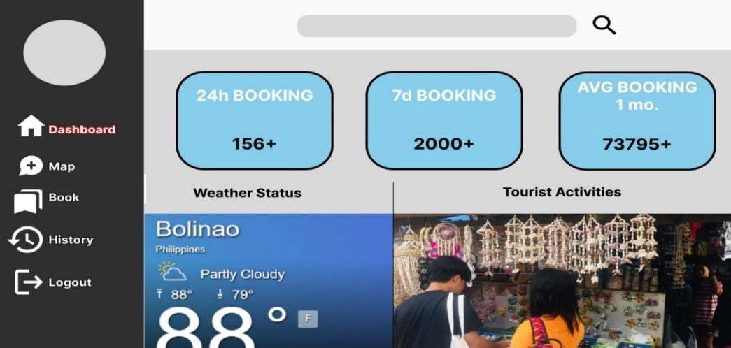

Figure 4:

Initial Dashboard

The dashboard is the page shown to the user where user activities are displayed, including real-time monitoring. Users can see the webpage's daily, weekly, and average booking activities.

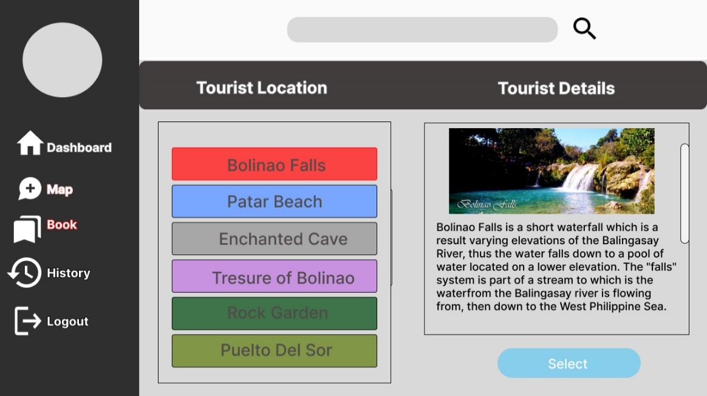

Figure 5:

Initial Booking Page

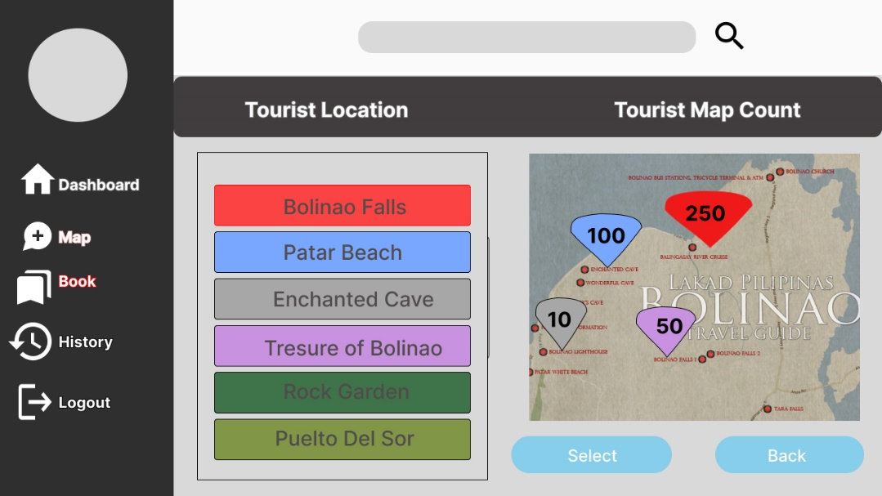 The Booking Page is the page shown when users book their chosen tourist location. Pictures are displayed to the users with brief descriptions of these selected tourist spots.

Figure 6:

Initial Map

The Map page will show the real-time monitoring feature of the system, where users will be able to see the current number of users/guests that booked in a specific tourist spot in the locale.

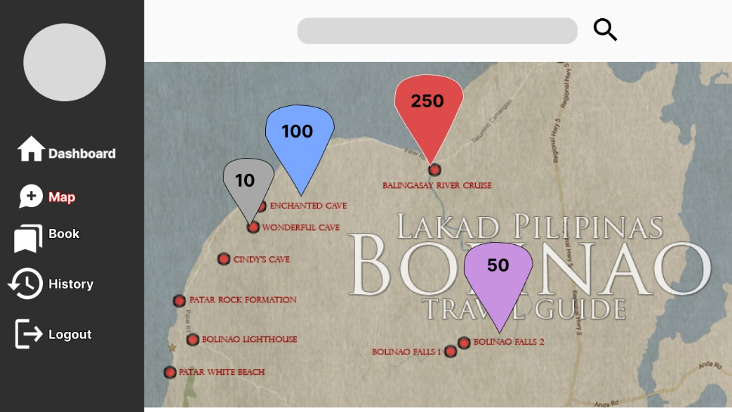

Figure 7:

Full-screen Map

# The Proposed Implementation Plan

The proponents created an implementation plan before completing the system. Once completed, the Tourism Monitoring System will be deployed to the target locale's Tourism Office for testing.

This will satisfy the objectives of the proponents while also ensuring that the deployment is carefully executed to avoid disrupting any actions or activities taking place in the Tourism Office.

Having prepared the web app, the proponents have located and marked the equipment per the approval of the organizations and assessed the operability of the completed system.

The recommended computer requirements for the implemented system were the following:

* Operating System: Windows 7 / 8 / 8.1 / 10 / 11
* Processor: Core i3 / Ryzen 3
* Disk space: 10 Gigabyte (GB)
* Memory: 4 Gigabyte (GB) RAM
* Network Interface Card with RJ-45 cables / Wi-Fi options.

After physically setting up the equipment that the proponents will install in the system, the testing procedure will begin.

The proponents have determined that the setup is suitable, and personnel from the Tourism Office of the LGU of Bolinao will be subject to train on the new system.

Table 4:

Implementation Plan

|  |  |  |  |
| --- | --- | --- | --- |
| **Strategy** | **Activity** | **Persons involved** | **Duration** |
| * Approval of the organization | * System proposal to the organization | * Proponents, * Project sponsor | 1 day |
| * System Installation | * System installation including prerequisite software and hardware | * Proponents | 4 hours |
| * Information Distribution | * Training and Manual(pdf) | * Proponents, * End User | 1 day |
| * User Training | * Hands-on training and a brief lecture | * Proponents, * End User | 1 day |

The Implementation Plan table shows the steps for implementing the system. It also displays the strategy, activity, people involved, and duration of each particular activity.